RBC Chromebooks

Network Connectivity:
In the bottom-right corner of the Chromebook screen, you’ll find the option to connect to a WiFi network. On campus, you should automatically connect to the “RBCChrome” network.

RBC Bookmarks:
When the browser opens, you will see a folder in the left corner called “RBC Bookmarks”. It has links to Statesman mail, Canvas, and other sites.

Saving your work:
- When you log out, the profile for this Chromebook will be cleared/deleted.
- The Chromebook will automatically log out after a period of inactivity.
- Therefore, you should save any work into the cloud/OneDrive, or a USB, and save often.
- If you need to use any Microsoft Office products, you will find them in Office365 online.
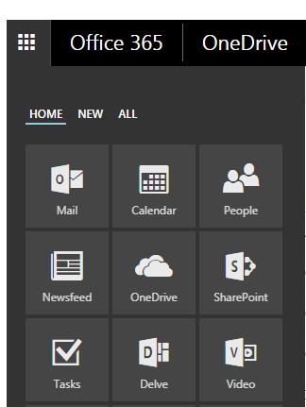
When you sign into Statesman mail, click on the grid box at the upper-left corner to access OneDrive, Word online, etc.

Printing on Campus:

- Your Chromebook must be on the RBCChrome wireless network.
- You may need to change your printer/print destination. Choose one that has the PaperCut Mobilty Print logo
- When you submit your print job, you will be prompted to log in: Use your RBC credentials.
- Not all printers shown will be available to students. Students have access to the LibraryCopier.

For Assistance:
- If you need help, please contact STAC: 804-862-6401 or stac@rbc.edu.
- You may also visit STAC in McNeer Hall, Room 110, during normal business hours: Mon-Fri, 8AM - 5PM.

